Economics Final Notes

# **Final:**

1. Explain different types of Elasticity of Demand.  
   Answer:   
   Elasticity of demand measures how the quantity demanded of a good responds to changes in its price. There are three main types of price elasticity of demand: elastic demand, inelastic demand, and unit elastic demand.  
     
   Elastic Demand (EP > 1): When the price elasticity of demand is greater than 1, demand is considered elastic. This means that a small percentage change in price results in a larger percentage change in the quantity demanded. In markets with elastic demand, consumers are highly responsive to price changes. A small increase in price leads to a substantial decrease in quantity demanded, and vice versa. This typically occurs for goods with many substitutes or non-essential items where consumers can easily switch to alternatives if the price rises. Luxury goods, such as high-end electronics or designer clothing, often exhibit elastic demand because consumers can forgo these purchases or opt for cheaper alternatives if prices rise.  
   Condition: %ΔQ > %ΔP  
   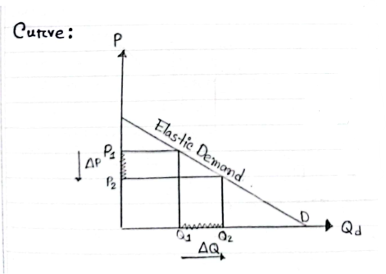  
   Graph Interpretation: The vertical axis (P) represents the price of the good, and the horizontal axis (Qd) represents the quantity demanded. The demand curve (D) is relatively flat, indicating that a small change in price (ΔP) leads to a large change in quantity demanded (ΔQ). When the price decreases from P1 to P2, the quantity demanded increases significantly from Q1 to Q2.  
     
   Inelastic Demand (EP < 1): When the price elasticity of demand is less than 1, demand is considered inelastic. This means that a percentage change in price results in a smaller percentage change in the quantity demanded. In markets with inelastic demand, consumers are less responsive to price changes. A significant change in price leads to a relatively small change in the quantity demanded. This typically occurs for essential goods or goods with few substitutes, where consumers cannot easily change their consumption habits despite price changes. Necessities, such as insulin for diabetics or basic utilities like water and electricity, often have inelastic demand because consumers need these goods regardless of price changes.  
   Condition: %ΔP > %ΔQ  
   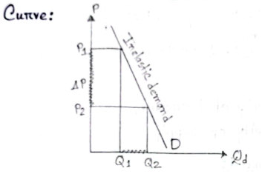  
   Graph Interpretation: The vertical axis (P) represents the price of the good, and the horizontal axis (Qd) represents the quantity demanded. The demand curve (D) is relatively steep, indicating that a large change in price (ΔP) leads to a small change in quantity demanded (ΔQ). When the price decreases from P1 to P2, the quantity demanded increases slightly from Q1 to Q2.  
     
   Unit Elastic Demand (EP = 1): When the price elasticity of demand is exactly 1, demand is considered unit elastic. This means that the percentage change in quantity demanded is equal to the percentage change in price. In this case, changes in price lead to proportional changes in quantity demanded. When demand is unit elastic, total revenue remains constant when the price changes. This balance is less common but important in understanding market dynamics where producers and consumers adjust precisely to price changes. Some goods, such as a specific brand of coffee, might exhibit unit elastic demand where a price increase of 10% results in a 10% decrease in quantity demanded, keeping the total expenditure the same.  
   Condition: %ΔQ = %ΔP  
   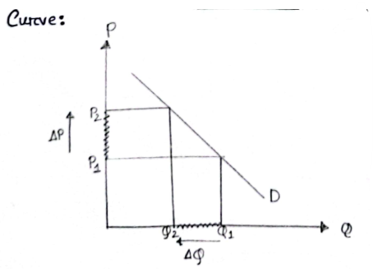  
   Graph Interpretation: The vertical axis (P) represents the price of the good, and the horizontal axis (Q) represents the quantity demanded. The demand curve (D) has a moderate slope, indicating that the percentage change in price (ΔP) is equal to the percentage change in quantity demanded (ΔQ). When the price decreases from P1 to P2, the quantity demanded increases from Q1 to Q2.
2. Explain different types of Elasticity of Supply.  
   Answer:   
   Elasticity of supply measures the responsiveness of the quantity supplied of a good to changes in its price. There are three main types of elasticity of supply: elastic supply, inelastic supply, and unit elastic supply.  
     
   Elastic Supply (ES > 1): When the elasticity of supply is greater than 1, supply is considered elastic. This means that a small percentage change in price results in a larger percentage change in the quantity supplied. In markets with elastic supply, producers can increase production quickly when prices rise, and reduce it just as quickly when prices fall. This typically occurs in industries where production can be scaled up or down without significant time delays or capital investments. For example, manufactured goods often exhibit elastic supply because production can be ramped up or down relatively easily.  
   Condition: %ΔQ > %ΔP  
   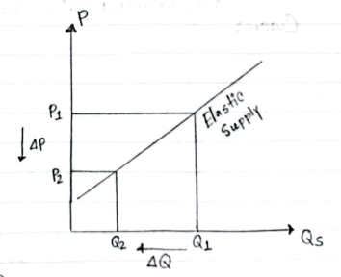  
   Graph Interpretation: The vertical axis (P) represents the price of the good, and the horizontal axis (Qs) represents the quantity supplied. The supply curve (S) is relatively flat, indicating that a small change in price (ΔP) leads to a large change in quantity supplied (ΔQ). When the price decreases from P1 to P2, the quantity supplied increases significantly from Q1 to Q2.  
     
   Inelastic Supply (ES < 1): When the elasticity of supply is less than 1, supply is considered inelastic. This means that a percentage change in price results in a smaller percentage change in the quantity supplied. In markets with inelastic supply, it is difficult for producers to change the quantity supplied quickly in response to price changes. This can be due to factors like long production times, high capital investment, or limited availability of inputs. For example: Agricultural products often have inelastic supply because crops need time to grow, and it is difficult to quickly increase or decrease production.  
   Condition: %ΔP > %ΔQ  
   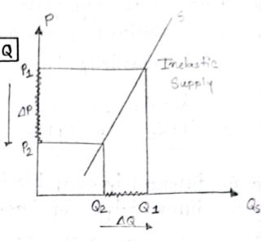  
   Graph Interpretation: The vertical axis (P) represents the price of the good, and the horizontal axis (Qs) represents the quantity supplied. The supply curve (S) is relatively steep, indicating that a large change in price (ΔP) leads to a small change in quantity supplied (ΔQ). When the price decreases from P1 to P2, the quantity supplied increases slightly from Q1 to Q2.  
     
   Unit Elastic Supply (ES = 1): When the elasticity of supply is exactly 1, supply is considered unit elastic. This means that the percentage change in quantity supplied is exactly equal to the percentage change in price. In this case, producers adjust their output proportionately to changes in price. This situation is less common and usually represents a balanced condition where changes in market conditions are perfectly matched by changes in supply. Some service industries might approach unit elasticity, where providers can adjust the amount of service offered in direct response to price changes.  
   Condition: %ΔQ = %ΔP  
   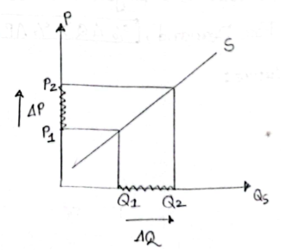  
   Graph Interpretation: The vertical axis (P) represents the price of the good, and the horizontal axis (Qs) represents the quantity supplied. The supply curve (S) has a moderate slope, indicating that the percentage change in price (ΔP) is equal to the percentage change in quantity supplied (ΔQ). When the price decreases from P1 to P2, the quantity supplied increases from Q1 to Q2.
3. Elasticity: Definition, Formula, Price Calculation, Explanation.  
   Answer:   
   Definition: Elasticity is an economic concept that measures the responsiveness of the quantity demanded or supplied of a good or service to changes in its price. Specifically, price elasticity of demand quantifies how much the quantity demanded of a good changes in response to a change in its price.  
     
   Formula: Price Elasticity, EP =   
   Explanation:   
   ΔQ = Q2 - Q1 (Change in quantity demanded)  
   ΔP = P2 - P1 (Change in price)  
   Q = $\frac{Q1 + Q2}{2}$ (Average quantity)  
   P = $\frac{P1 + P2}{2}$ (Average price)
4. Describe Price Elasticity of Demand with the help of diagrams.  
   Answer:   
   Price elasticity of demand (EP) measures the responsiveness of the quantity demanded of a good or service to changes in its price. It quantifies how much the quantity demanded will change in response to a change in price.  
     
   After that, Refer to **Question No. 1**
5. Describe Price Elasticity of supply with the help of diagrams.  
   Answer:   
   Price elasticity of supply (ES) measures the responsiveness of the quantity supplied of a good to changes in its price. It indicates how much the quantity supplied will change in response to a change in price.  
     
   After that, Refer to **Question No. 2**
6. Calculate Price Elasticity and give interpretation:

| Q | P |
| --- | --- |
| 10 | 5 |
| 15 | 10 |
| 25 | 12 |
| 30 | 15 |
| 40 | 20 |

Answer:

Given,

Q1 = 10, P1 = 5

Q2 = 15, P2 = 10

∴ ΔQ = (Q2 - Q1) = (15 - 10) = 5

∴ ΔP = (P2 - P1) = (10 - 5) = 5

∴ Q = $\frac{Q1 + Q2}{2} = \frac{10 + 15}{2} = 12.5$

∴ P = $\frac{P1 + P2}{2} = \frac{5 + 10}{2} = 7.5$

∴ EP =

Here, Price Elasticity is less than 1. Which means it is Inelastic and as it is 0.6, it is positive, meaning it’s a supply graph. So 1% increase in price leads to 0.6% increase in quantity supplied.

Again, given,

Q2 = 15, P2 = 10

Q3 = 25, P3 = 12

∴ ΔQ = (Q3 - Q2) = (25 - 15) = 10

∴ ΔP = (P3 - P2) = (12 - 10) = 2

∴ Q = $\frac{Q2 + Q3}{2} =\frac{15 + 25}{2} = 20$

∴ P = $\frac{P2 + P3}{2} =\frac{10 + 12}{2} = 11$

∴ EP =

Here, Price Elasticity is greater than 1. Which means it is Elastic and as it is 2.75, it is positive, meaning it’s a supply graph. So 1% increase in price leads to 2.75% increase in quantity supplied.

Again, given,

Q3 = 25, P3 = 12

Q4 = 30, P4 = 15

∴ ΔQ = (Q4 - Q3) = (30 - 25) = 5

∴ ΔP = (P4 - P3) = (15 - 12) = 3

∴ Q = $\frac{Q3+ Q4}{2} =\frac{25 + 30}{2} = 27.5$

∴ P = $\frac{P3 + P4}{2} =\frac{12 + 15}{2} = 13.5$

∴ EP =

As, EP < 1. So, it is Inelastic and also 0.82 is positive. So it is a supply graph. So 1% increase in price leads to 0.82% increase in quantity supplied.

Again, given,

Q4 = 30, P4 = 15

Q5 = 40, P5 = 20

∴ ΔQ = (Q5 - Q4) = (40 - 30) = 10

∴ ΔP = (P5 - P4) = (20 - 15) = 5

∴ Q = $\frac{Q4 + Q5}{2} =\frac{30 + 40}{2} = 35$

∴ P = $\frac{P4 + P5}{2} =\frac{15 + 20}{2} = 17.5$

∴ EP =

Here, Price Elasticity is equal to 1. Which means it is Unit elastic and as it is 1, it is positive, meaning it’s a supply graph. So 1% increase in price leads to 1% increase in quantity supplied.

1. True/ False. Give explanation:
   1. When demand is price Inelastic, a price decrease reduces total revenue.  
      Answer:   
      True: When demand price is Inelastic, a price decrease reduces total revenue.  
      Explanation: In price inelastic demand, the %Δ in quantity is less than the %Δ change in price. This means that when price decreases, the increase in quantity demanded is proportionally smaller, resulting in decrease in total revenue. In other words, the decrease in price doesn't lead to a significant enough increase in sales to offset the price reduction.  
      Explanation: Consider medicine for Health conditions. If the price of these medications decreases, people who need them will still buy them because they are essential, even though their price has dropped . The increase in quantity demand will be less than the price reduction, leading to a decrease in total revenue.  
      Curve:   
      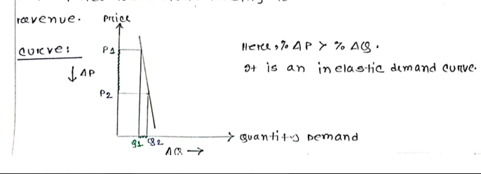  
      Graph Interpretation: The vertical axis represents the price, and the horizontal axis represents the quantity demanded. The demand curve (D) is relatively steep, indicating that a large change in price (ΔP) leads to a small change in quantity demanded (ΔQ). When the price decreases from P1 to P2, the quantity demanded increases slightly from Q1 to Q2.
   2. When demand is price Elastic, a price decrease increases total revenue.

Answer:   
True: When demand price is Elastic, a price decrease increases total revenue.  
Explanation: In price Elastic demand, the %Δ in quantity is greater than the %Δ change in price. This means that when price decreases, the increase in quantity demanded is proportionally larger, resulting in an increase in total revenue. In other words, the decrease in price leads to a significant enough increase in sales more than offset the price reduction.  
Explanation: If the price of a smartphone decreases, more people will buy it, resulting in a substantial increase in sales. The higher quantity demanded will lead to higher total revenue even though that has been lowered since revenue = price * quantity.  
Curve:

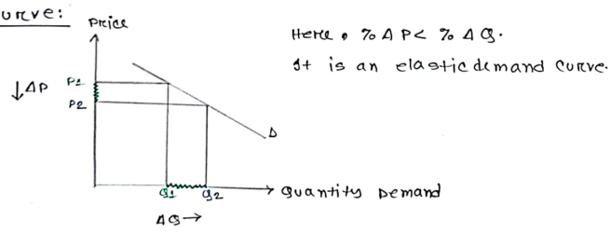  
Graph Interpretation: The vertical axis represents the price, and the horizontal axis represents the quantity demanded. The demand curve (D) is relatively flat, indicating that a small change in price (ΔP) leads to a large change in quantity demanded (ΔQ). When the price decreases from P1 to P2, the quantity demanded increases significantly from Q1 to Q2.

1. True/ False. Give explanation:
   1. When demand is price Inelastic, a price increase reduces total revenue.  
      Answer:  
      False: When demand price is Inelastic, a price decrease DOES NOT REDUCE total revenue.  
      Explanation: In price inelastic demand, the %Δ in quantity is less than the %Δ change in price. This means that when price decreases, the increase in quantity demanded is proportionally smaller, resulting in decrease in total revenue. In other words, the decrease in price doesn't lead to a significant enough increase in sales to offset the price reduction.  
      Explanation: Consider medicine for Health conditions. If the price of these medications decreases, people who need them will still buy them because they are essential, even though their price has dropped . The increase in quantity demand will be less than the price reduction, leading to a decrease in total revenue.
   2. When demand is price Elastic, a price increase increases total revenue.  
      Answer:  
      False: When demand price is Elastic, a price decrease DOES NOT INCREASE total revenue.  
      Explanation: In price Elastic demand, the %Δ in quantity is greater than the %Δ change in price. This means that when price decreases, the increase in quantity demanded is proportionally larger, resulting in an increase in total revenue. In other words, the decrease in price leads to a significant enough increase in sales more than offset the price reduction.  
      Explanation: If the price of a smartphone decreases, more people will buy it, resulting in a substantial increase in sales. The higher quantity demanded will lead to higher total revenue even though that has been lowered since revenue = price * quantity.
2. Surplus  
   Answer:   
   Definition:  
   Surplus in economics refers to the amount by which the quantity supplied of a product exceeds the quantity demanded at a given price. This can occur in markets where the price is set above the equilibrium price, leading to excess supply. There are different types of surplus, including consumer surplus, producer surplus, and economic surplus.  
     
   Types of Surplus:  
   **Consumer Surplus:** This is the difference between what consumers are willing to pay for a good or service and what they actually pay. It represents the benefit consumers receive from purchasing at a market price lower than their maximum willingness to pay.  
   **Producer Surplus:** This is the difference between what producers are willing to accept for a good or service and the price they actually receive. It represents the benefit producers receive from selling at a market price higher than their minimum acceptable price.  
   Total Surplus: This is the sum of consumer and producer surplus. It represents the total benefit to society from the production and consumption of goods and services.  
     
   Formula: Total Surplus (TS) = Consumer Surplus (CS) + Producer Surplus (PS)  
     
   Surplus arises in markets due to the interaction between supply and demand. When the market price is above the equilibrium price, it results in a surplus because the quantity supplied exceeds the quantity demanded. Conversely, when the market price is below the equilibrium price, it results in a shortage because the quantity demanded exceeds the quantity supplied. The concept of surplus is crucial for understanding market efficiency and welfare economics.
3. Calculate total Surplus  
   P= 50-Q  
   P= 20+2Q  
   Answer:   
   Given,  
    P = 50 - Q ……………… (i)  
    P = 20 + 2Q ……………. (ii)  
     
   We know,  
    Total Surplus = Consumer Surplus + Producer Surplus  
    => TS = CS + PS  
     
   To calculate Total Surplus we need to find the Equilibrium Price and Quantity by setting the two given equations for price equal.  
    ∴ 50 - Q = 20 + 2Q  
    => 2Q + Q = 50 - 20  
    => 3Q = 30  
    ∴ Q* = 30/ 3 = 10  
    ∴ P* = 50 - Q = 50 - 10 = 40  
     
   Now in equation (i) taking P = 0 & Q = 0 at a time, we get,  
    Q = 50 and P = 50  
     
   Again, in equation (ii) taking P = 0 & Q = 0 at a time, we get,  
    Q = 10 and P = 20  
     
   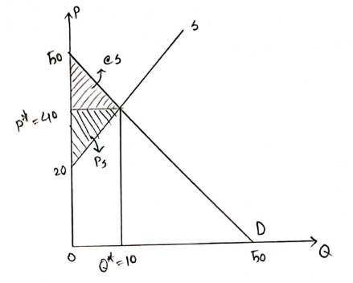  
   Graph Interpretation: The vertical axis (P) represents the price, and the horizontal axis (Q) represents the quantity. The demand curve (D) and the supply curve (S) is moderate, indicating that the intersection point is the Equilibrium (E). So the P* = 40 is the Equilibrium Price and Q* = 10 is the Equilibrium Quantity. The highlighted triangles are CS (Consumer Surplus) and PS (Producer Surplus).  
     
   ∴ Consumer Surplus, CS = $\frac{1}{2} × 10 × (50 - 40)$ = 50  
   ∴ Producer Surplus, PS = $\frac{1}{2} × 10 × (40 - 20)$ = 100  
   ∴ Total Surplus = Consumer Surplus + Producer Surplus  
    = CS + PS  
    = 50 + 100  
    = 150 [Answer]
4. Revenue  
   Answer:   
   Definition:  
   Revenue, often referred to as sales or turnover, is the total amount of money generated by a company from its business activities, usually from the sale of goods and services to customers. It is a critical financial metric indicating the effectiveness of a company in generating sales and plays a vital role in profitability analysis.  
     
   Explanation:  
   Revenue is typically reported at the top of the income statement, earning it the nickname "top line." It includes all income from the core business operations but excludes any other sources of income such as interest or investment gains.  
     
   Formula: Revenue = Number of Units Sold * Price per Unit  
     
   Examples:  
   1. A clothing store sells 1,000 shirts at $20 each. The revenue from this sale would be 1,000 * $20 = $20,000.  
   2. A consulting firm charges $150 per hour. If they provide 100 hours of consulting in a month, the revenue would be 100 * $150 = $15,000.  
   3. A software company offers a subscription at $10 per month. With 500 subscribers, the monthly revenue would be 500 * $10 = $5,000.
5. Explain GDP and GNP.  
   Answer:   
   GDP (Gross Domestic Product):   
     
   Definition and Purpose: GDP is a key macroeconomic indicator that measures the total market value of all final goods and services produced within a country's borders in a given year. It is used to assess the economic performance of a country and is a fundamental component of national accounts, helping policymakers determine economic growth, recession, or inflation.  
     
   GDP is the sum of four main components:   
   Consumption (C): Total spending by households on goods and services.  
   Investment (I): Total spending on capital goods that will be used for future production.  
   Government Expenditure (G): Total government expenditures on goods and services.  
   Net Exports (NX): The value of a country's exports minus its imports.  
     
   Mathematically, GDP is expressed as: GDP = C + I + G + NX  
     
   GDP is widely used to gauge the overall health and size of an economy. It is essential for comparing the economic performance of different countries and for making economic policies.  
     
   GNP (Gross National Product):   
     
   Definition and Purpose: GNP measures the total economic output produced by the resources owned by a country’s residents, irrespective of whether the production occurs within the country or abroad. It accounts for the income earned by residents from abroad and excludes income earned by foreign residents within the country.  
     
   GNP includes:   
   GDP (Gross Domestic Product)  
   Z (Net Income Flow) = Income Inflow - Income Outflow  
     
   Mathematically, GNP is expressed as: GNP = GDP + Z  
     
   Where Z represents the net income flow, which is calculated as income inflow (income earned by residents from abroad) minus income outflow (income earned by foreign residents within the country). So, Z = income inflow - income outflow.  
     
   For example, think about a Honda car factory in the United States, which is owned by a Japanese company. The money it makes goes into the U.S. GDP because it adds to the United States' economy. But it doesn't count in the U.S. GNP because it's owned by a Japanese company. And if an American economist goes to Japan to give a lecture and gets paid for it, that money gets counted in Japan's GDP because it happens in Japan. But it also gets counted in America's GNP because the economist is from the United States.  
     
   GNP provides a more comprehensive measure of a country’s economic performance by including international economic activities and gives insights into the income generated by its residents, whether within or outside the country.
6. Difference Between GDP and GNP.  
   Answer:   
   Differences Between GDP and GNP:

| Aspects | GDP (Gross Domestic Product) | GNP (Gross National Product) |
| --- | --- | --- |
| Definition | Total market value of all final goods and services produced within a country during a specific period. | Total market value of all final goods and services produced using resources owned by the residents of a country, regardless of where the production takes place. |
| Scope | Measures economic activity within the country's borders. | Measures economic activity based on the ownership of resources, regardless of location. |
| Income Flows | Includes income generated by foreign-owned businesses within the country. | Includes income earned by residents from abroad, excludes income earned by foreign residents within the country. |
| Formula | GDP = C (Consumption) + I (Investment) + G (Government Spending) + NX (Net Exports) | GNP = GDP (Gross Domestic Product) + Z (Net Income Flow) Where, Z = Income Inflow - Income Outflow |
| Example | A Japanese-owned factory in the U.S. counts towards U.S. GDP. | Income earned by an American economist working in Japan counts towards U.S. GNP. |
| Usage | Commonly used to compare the economic performance of different countries and regions. | Provides insights into the total economic strength of a country’s residents, including their global economic activities. |
| Focus | Domestic production. | Ownership of production, including international aspects. |
| Purpose | Gauges overall health and size of an economy. | Measures total economic output of a country’s residents. |
| Policy Implications | Influences domestic economic policies focusing on internal growth and stability. | Influences economic policies considering international income flows and investments. |

1. Explain different methods of calculating GDP (Output Method, Income Method, Expenditure Method)  
   Answer:   
   Methods of Calculating GDP:   
     
   1. Output Method: The Output Method, also known as the Production Method or Value-Added Method, calculates GDP by summing the value of all goods and services produced in the economy, subtracting the cost of intermediate goods and services used in the production process.  
   Formula: GDP = Value of total final goods or services - Value of intermediate goods or services  
   Explanation:   
   A. Gross Value of Output: The total value of all goods and services produced by all sectors of the economy over a period of time.  
   B. Value of Intermediate Consumption: The value of goods and services used as inputs in the production of final goods and services.  
   Example:   
   If a pen manufacturer produces pens worth $100,000 and the cost of ink and plastic (intermediate goods) used in production is $40,000, the GDP contribution of the pen manufacturer is: GDP = $100,000 - $40,000 = $60,000  
   This method emphasizes the value added at each stage of production, avoiding double-counting of intermediate goods.  
     
   2. Income Method: The Income Method calculates GDP by summing all incomes earned by factors of production in an economy. This method focuses on the income side, emphasizing how much is earned from producing goods and services within the country.  
   Formula: GDP = Wages + Interest + Rental Income + Firm Profits + ... + Other Incomes  
   Explanation:   
   A. Wages and Salaries: Income earned by labor.  
   B. Interest: Income earned from lending capital.  
   C. Rental Income: Income earned by property owners.  
   D. Firm Profits: Income earned by businesses after accounting for all costs.  
   E. Other Incomes: Includes income from royalties, dividends, and other sources of earnings.  
   Example:   
   Let's consider a simplified economy with the following income components:  
   - Wages: $500 billion

- Interest: $50 billion

- Rental Income: $100 billion

- Firm Profits: $200 billion

- Other Incomes (including dividends, royalties): $50 billion  
Thus, the GDP using the Income Method would be calculated as follows:  
GDP = Wages + Interest + Rental Income + Firm Profits + Other Incomes  
 = $500 billion + $50 billion + $100 billion + $200 billion + $50 billion  
 = $900 billion  
  
3. Expenditure Method: The Expenditure Method calculates GDP by summing all expenditures or spending on final goods and services in an economy during a specific period.  
Formula: GDP = C (Consumption) + I (Implement ) + G (Government Expenditure) + NX (Net Exports)  
Explanation:   
A. Consumption (C): Total spending by households on goods and services (e.g., food, clothing, rent).  
B. Investment (I): Total spending on capital goods that will be used for future production (e.g., machinery, buildings).  
C. Government Spending (G): Total government expenditures on goods and services (e.g., salaries of public servants, defense)  
D. Net Exports (NX): The value of exports minus the value of imports. A positive net export means the country exports more than it imports, contributing positively to GDP.  
Example:   
If in a given year, household consumption is $3 trillion, investments amount to $1 trillion, government spending is $1.5 trillion, exports are $0.5 trillion, and imports are $0.7 trillion, the GDP would be:  
GDP: $3 trillion + $1 trillion + $1.5 trillion + ($0.5 trillion- $0.7 trillion) =   
This method focuses on the total expenditure made on the nation's final goods and services.

1. 100% confirmed to come in Final Exam - Impact on Padma Bridge on the Bangladesh Economy.  
   Answer:   
   The Padma Bridge, inaugurated in 2022, is a landmark infrastructure project in Bangladesh. It serves as a critical link between the capital, Dhaka, and 21 southwestern districts, previously isolated due to the formidable Padma River. This improved connectivity has significant positive impacts on the Bangladesh economy, as detailed below:  
     
   1. Enhanced Connectivity:

- The Padma Bridge connects the southwestern region of Bangladesh with the capital Dhaka and other parts of the country.

According to the Asian Development Bank (ADB), 27% of the total population of Bangladesh lives in the south-west. The Padma river is a considerable obstacle while transporting anything from Bangladesh’s Barisal and Khulna to Dhaka. The Padma Bridge will carry an average of 24,000 vehicles per day in 2024 and 67,000 by 2050.

- It reduces travel time between Dhaka and the southwestern districts by approximately 2-3 hours, promoting easier and faster transportation of goods and people.   
  
2. Economic Growth:

- The bridge is expected to boost Bangladesh's GDP by 1.23% annually. At the same time, with the completion of the Padma Bridge Rail Link project, GDP will grow by another 1 percent.

- It aims to stimulate regional economic activities, particularly in the underdeveloped southwestern districts.  
  
3. Trade and Commerce:

- The bridge facilitates smoother logistics for trade and commerce, enhancing connectivity to the Mongla Port and Benapole Land Port. In addition, the Padma Bridge will reduce the distance from Mongla Port to Dhaka by more than 100 km to only 170 km, whereas the current distance between Chittagong Port and Dhaka is about 264 km.

- It is anticipated to increase trade activities, contributing significantly to national economic growth.

The distance from Dhaka to Kolkata via Jessore will be reduced to half, and it will take only 3 to 4 hours, which will also boost the country’s international trading.  
  
4. Investment and Industrialization:

- The improved infrastructure is likely to attract both domestic and foreign investment in the southwestern region. The changes in the economy of North Bengal as a result of this bridge have contributed about 2% to the GDP growth of Bangladesh

- Potential growth in industrial zones and economic hubs along the bridge route is expected to create numerous job opportunities.  
  
5. Agriculture and Rural Development:

- The southwestern region, known for its agricultural productivity, benefits from better market access.

- Farmers can now transport their products more efficiently, potentially increasing their income and reducing post-harvest losses.

As a result, farmers and producers will get better prices for their produce, which will increase their quality of life. According to a study by the World Bank, about 30 million people in Bangladesh will directly benefit from the Padma Bridge.  
  
6. Tourism:

- The Padma Bridge opens up new possibilities for tourism in the southwestern region, known for its natural beauty and heritage sites.

- Improved accessibility is expected to boost local tourism industries and associated businesses.  
  
7. Cost and Financing:

- The total cost of the Padma Bridge project is estimated at $3.86 billion.

- The project is funded primarily by the Bangladesh government, highlighting the country's commitment to self-financed large-scale infrastructure projects.  
  
8. Social Impact:

- Enhanced connectivity is expected to improve access to education and healthcare facilities for people in the southwestern region. The work on the planned handloom estate, which will showcase the regional weaving heritages and specialities like muslin, jamdani and Monipuri has gained pace.

- The bridge promotes social inclusion by integrating isolated communities into the national mainstream. The Bridge will also help to reach people with relief and assistance during any natural disaster.  
  
9. Regional Development:

- The bridge plays a crucial role in the government's goal to decentralize economic activities and reduce regional disparities. It will create 7.5 lakh new jobs in 17 special economic zones planned in 21 districts, contributing greatly to poverty reduction.

- It is a cornerstone of Bangladesh's broader infrastructure development strategy, aiming to create a more balanced and inclusive economic landscape. The international road and rail transport network will promote trans-border ties as well as cultural development of the Eastern Region of the Indian Subcontinent  
  
10. Environmental and Resettlement Considerations:

- The construction included significant measures to mitigate environmental impact and ensure proper resettlement of affected communities.

- Long-term environmental monitoring and management plans are in place to sustain the ecological balance around the bridge area.

# **MID - Demand & Supply:**

1. Explain Demand Theory  
   Answer: Demand theory is an economic principle that describes the relationship between the price of goods and services and the demand for them in a market if other things remain constant (*Ceteris Paribus -> If other things remain constant*). It describes the way that changes in quantity demand(Qd) of any goods, products or services demanded by consumers when its price in the market is affected.

It states that when the price(P) of a good or service increases, the quantity demand(Qd) decreases, and when the price(P) of a good or service decreases, the quantity demand(Qd) increases.

**P↑ (Qd) ↓**

**P↓ (Qd) ↑**

1. Q = 10 - 2P; Calculate the Slope and Interpretation of the following Function.  
   Answer: Given equation,

Q = 10 - 2P

When,

P = 1, Q = 8

P = 2, Q = 6

P = 3, Q = 4

P = 4, Q = 2

If we plot the points in graph -

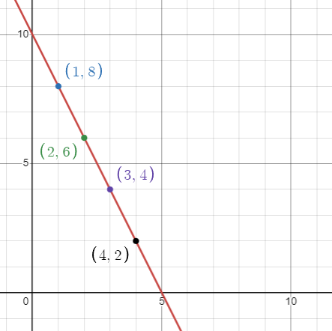

Here slope = $\frac{d}{dP}$ (Q)

= $\frac{d}{dP}$ (10 - 2P)

= -2

∴ slope = -2.

Here we can see that -

The curve is a downward sloping curve. As the slope is negative.

There is a negative relationship between Price & Quantity.

So it supports demand theory. The given equation is a Demand function.

1. Explain the Effect of Change in Price on Demand.  
   Answer: Price is a factor of Demand. There is an inverse relationship between the price of a good or service and the quantity demanded by consumers. When Price increases the quantity demand(Qd) decreases, when Price decreases the quantity demand(Qd) increases.

**P↑ (Qd) ↓**

**P↓ (Qd) ↑**

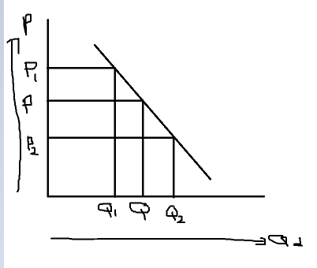

When,

Price(P) increases from P to P1 the quantity demand(Qd) decreases from Q to Q1.

Price(P) decreases from P to P2 the quantity demand(Qd) increases from Q to Q2.

Hence for the changes in price the quantity demand(Qd) moves along the curve.

1. Explain the Effect of Change in Income on Demand.  
   Answer: Income is a factor of Demand. There is a direct relationship between the income of consumers and the quantity demanded by consumers. When income increases the quantity demand(Qd) increases, when income decreases the quantity demand(Qd) decreases.

**I↑ (Qd) ↑**

**I↓ (Qd) ↓**

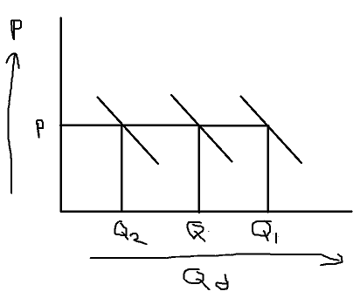

When,

Income(I) increases the quantity demand(Qd) increases from Q to Q1.

Income(I) decreases the quantity demand(Qd) decreases from Q to Q2.

Hence for the change in Income the quantity demand(Qd) moves along the axis.

1. Explain the Effect of Change in Population on Demand.  
   Answer: Population is a factor of Demand. There is a direct relationship between the population and the quantity demanded by consumers. When population increases the quantity demand(Qd) increases, when population decreases the quantity demand(Qd) decreases.

**P↑ (Qd) ↑**

**P↓ (Qd) ↓**

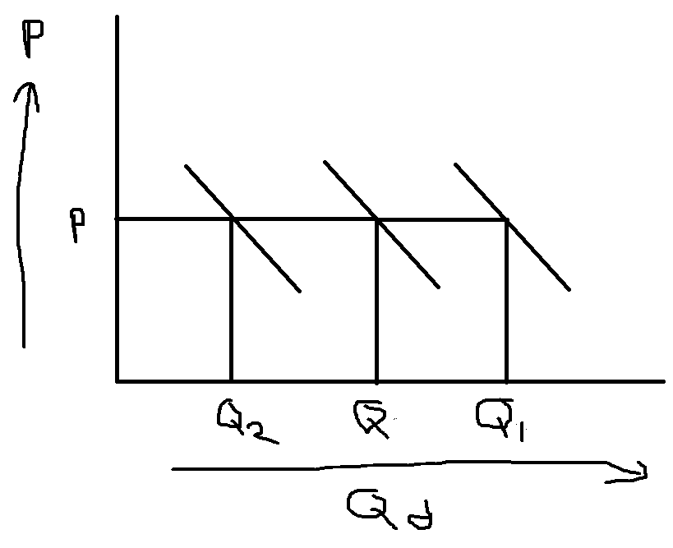

When,

Population(P) increases the quantity demand(Qd) increases from Q to Q1.

Population(P) decreases the quantity demand(Qd) decreases from Q to Q2.

Hence for the change in population the quantity demand(Qd) moves along the axis.

1. Explain the Effect of Change in Price of Related Goods on Demand.  
   Answer: Price of related goods is a factor of Demand. There is a direct relationship between the price of related goods and the quantity demanded by consumers. When Price of related goods increases the quantity demand(Qd) increases, when the price of related goods decreases the quantity demand(Qd) decreases.

**Prg↑ (Qd) ↑**

**Prg↓ (Qd) ↓**



When,

price of related goods (Prg) increases the quantity demand(Qd) increases from Q to Q1.

price of related goods (Prg) decreases the quantity demand(Qd) decreases from Q to Q2.

Hence for the change in price of related goods the quantity demand(Qd) moves along the axis.

1. Explain Supply Theory.  
   Answer: Supply theory is an economic principle that describes the relationship between the price of goods and services and the supply of them in a market if other things remain constant (*Ceteris Paribus -> If other things remain constant*). It describes the way that changes in quantity supply(Qs) of any goods, products or services supplied by any seller or manufacturer when its price in the market is affected.

It states that when the price(P) of a good or service increases, the quantity supply(Qs) increases, and when the price(P) of a good or service decreases, the quantity supply(Qs) decreases.

**P↑ (Qs) ↑**

**P↓ (Qs) ↓**

1. Q = 1 + 2P; Calculate Slope and give Interpretation of the following Function..  
   Answer: Given equation,

Q = 1 + 2P

When,

P = 1, Q = 3

P = 2, Q = 5

P = 3, Q = 7

P = 4, Q = 9

If we plot the points in graph -

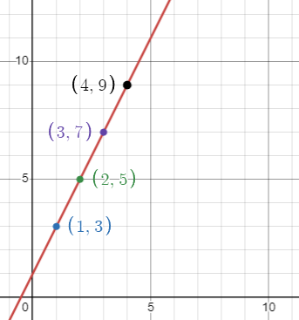

Here slope = $\frac{d}{dP}$ (Q)

= $\frac{d}{dP}$ (1 + 2P)

= 2

∴ slope = 2.

Here we can see that -

The curve is an upward sloping curve. As the slope is positive.

There is a positive relationship between Price & Quantity.

So it supports supply theory. The given equation is a supply function.

1. Explain the factors affecting Supply.  
   Answer: There are 3 factors that effect’s supply -

* Price.
* Input Price.
* Government Policy or Tax.

Price is a factor of Supply. There is a direct relationship between the price of a goods or services and the quantity supplied by sellers. When Price increases the quantity supply(Qs) increases, when Price decreases the quantity demand(Qd) decreases.

**P↑ (Qs) ↑**

**P↓ (Qs) ↓**

**গ্রাফ আকা বাকি….**

Input price is a factor of Supply. There is an inverse relationship between the input price of a goods or services and the quantity supplied by sellers. When input price increases the quantity supply(Qs) decreases, when Input price decreases the quantity demand(Qs) increases.

**Ip↑ (Qs) ↓**

**Ip↓ (Qs) ↑**

**গ্রাফ আকা বাকি….**

Government policy or Tax is a factor of Supply. There is an inverse relationship between the tax on any goods or services and the quantity supplied by sellers. When Tax increases the quantity supply(Qs) decreases, when Tax decreases the quantity demand(Qs) increases.

**Tax↑ (Qs) ↓**

**Tax↓ (Qs) ↑**

**গ্রাফ আকা বাকি….**

1. Explain Equilibrium.  
   Answer:
2. Q = 100 - 2P, Q = 10 + P, Calculate P* and Q* (Condition D = S).  
   Answer:   
   We know,  
    D = S  
    => 100 - 2P = 10 + P  
    => -2P - P = 10 - 100  
    => -3P = 90  
    ∴ P = 30  
     
   Here,  
    Q = 10 + P = 10 + 30 = 40  
     
   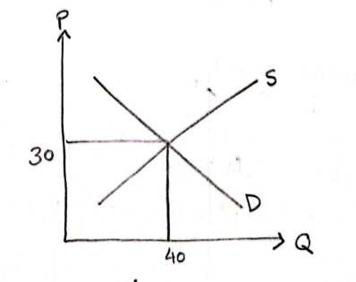
3. Explain the Effect of Change in Income on Equilibrium Price and Quantity.  
   Answer: